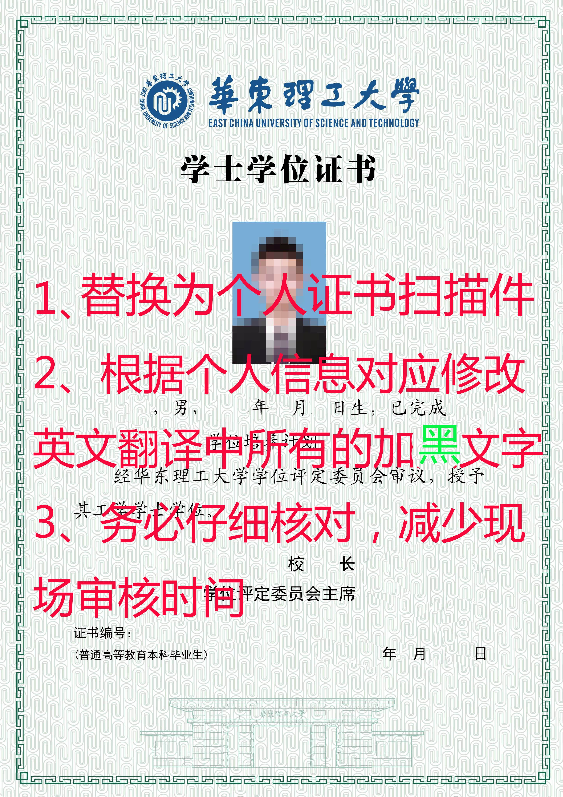
CERTIFICATE
( Translation )

We hereby certify that Sanmao Zhang, Male, born on 28th July, 1996，majored in Material Chemistry and fulfilled all the requirements prescribed for graduation.
Upon the evaluation of the Degrees Awarding Committee of this university, Sanmao Zhang is awarded the Degree of Bachelor of Engineering.

President
Chairman of the Degrees Awarding Committee: Qu Jingping
East China University of Science and Technology

Certificate No:12342567890 Issued on 1st July,2019
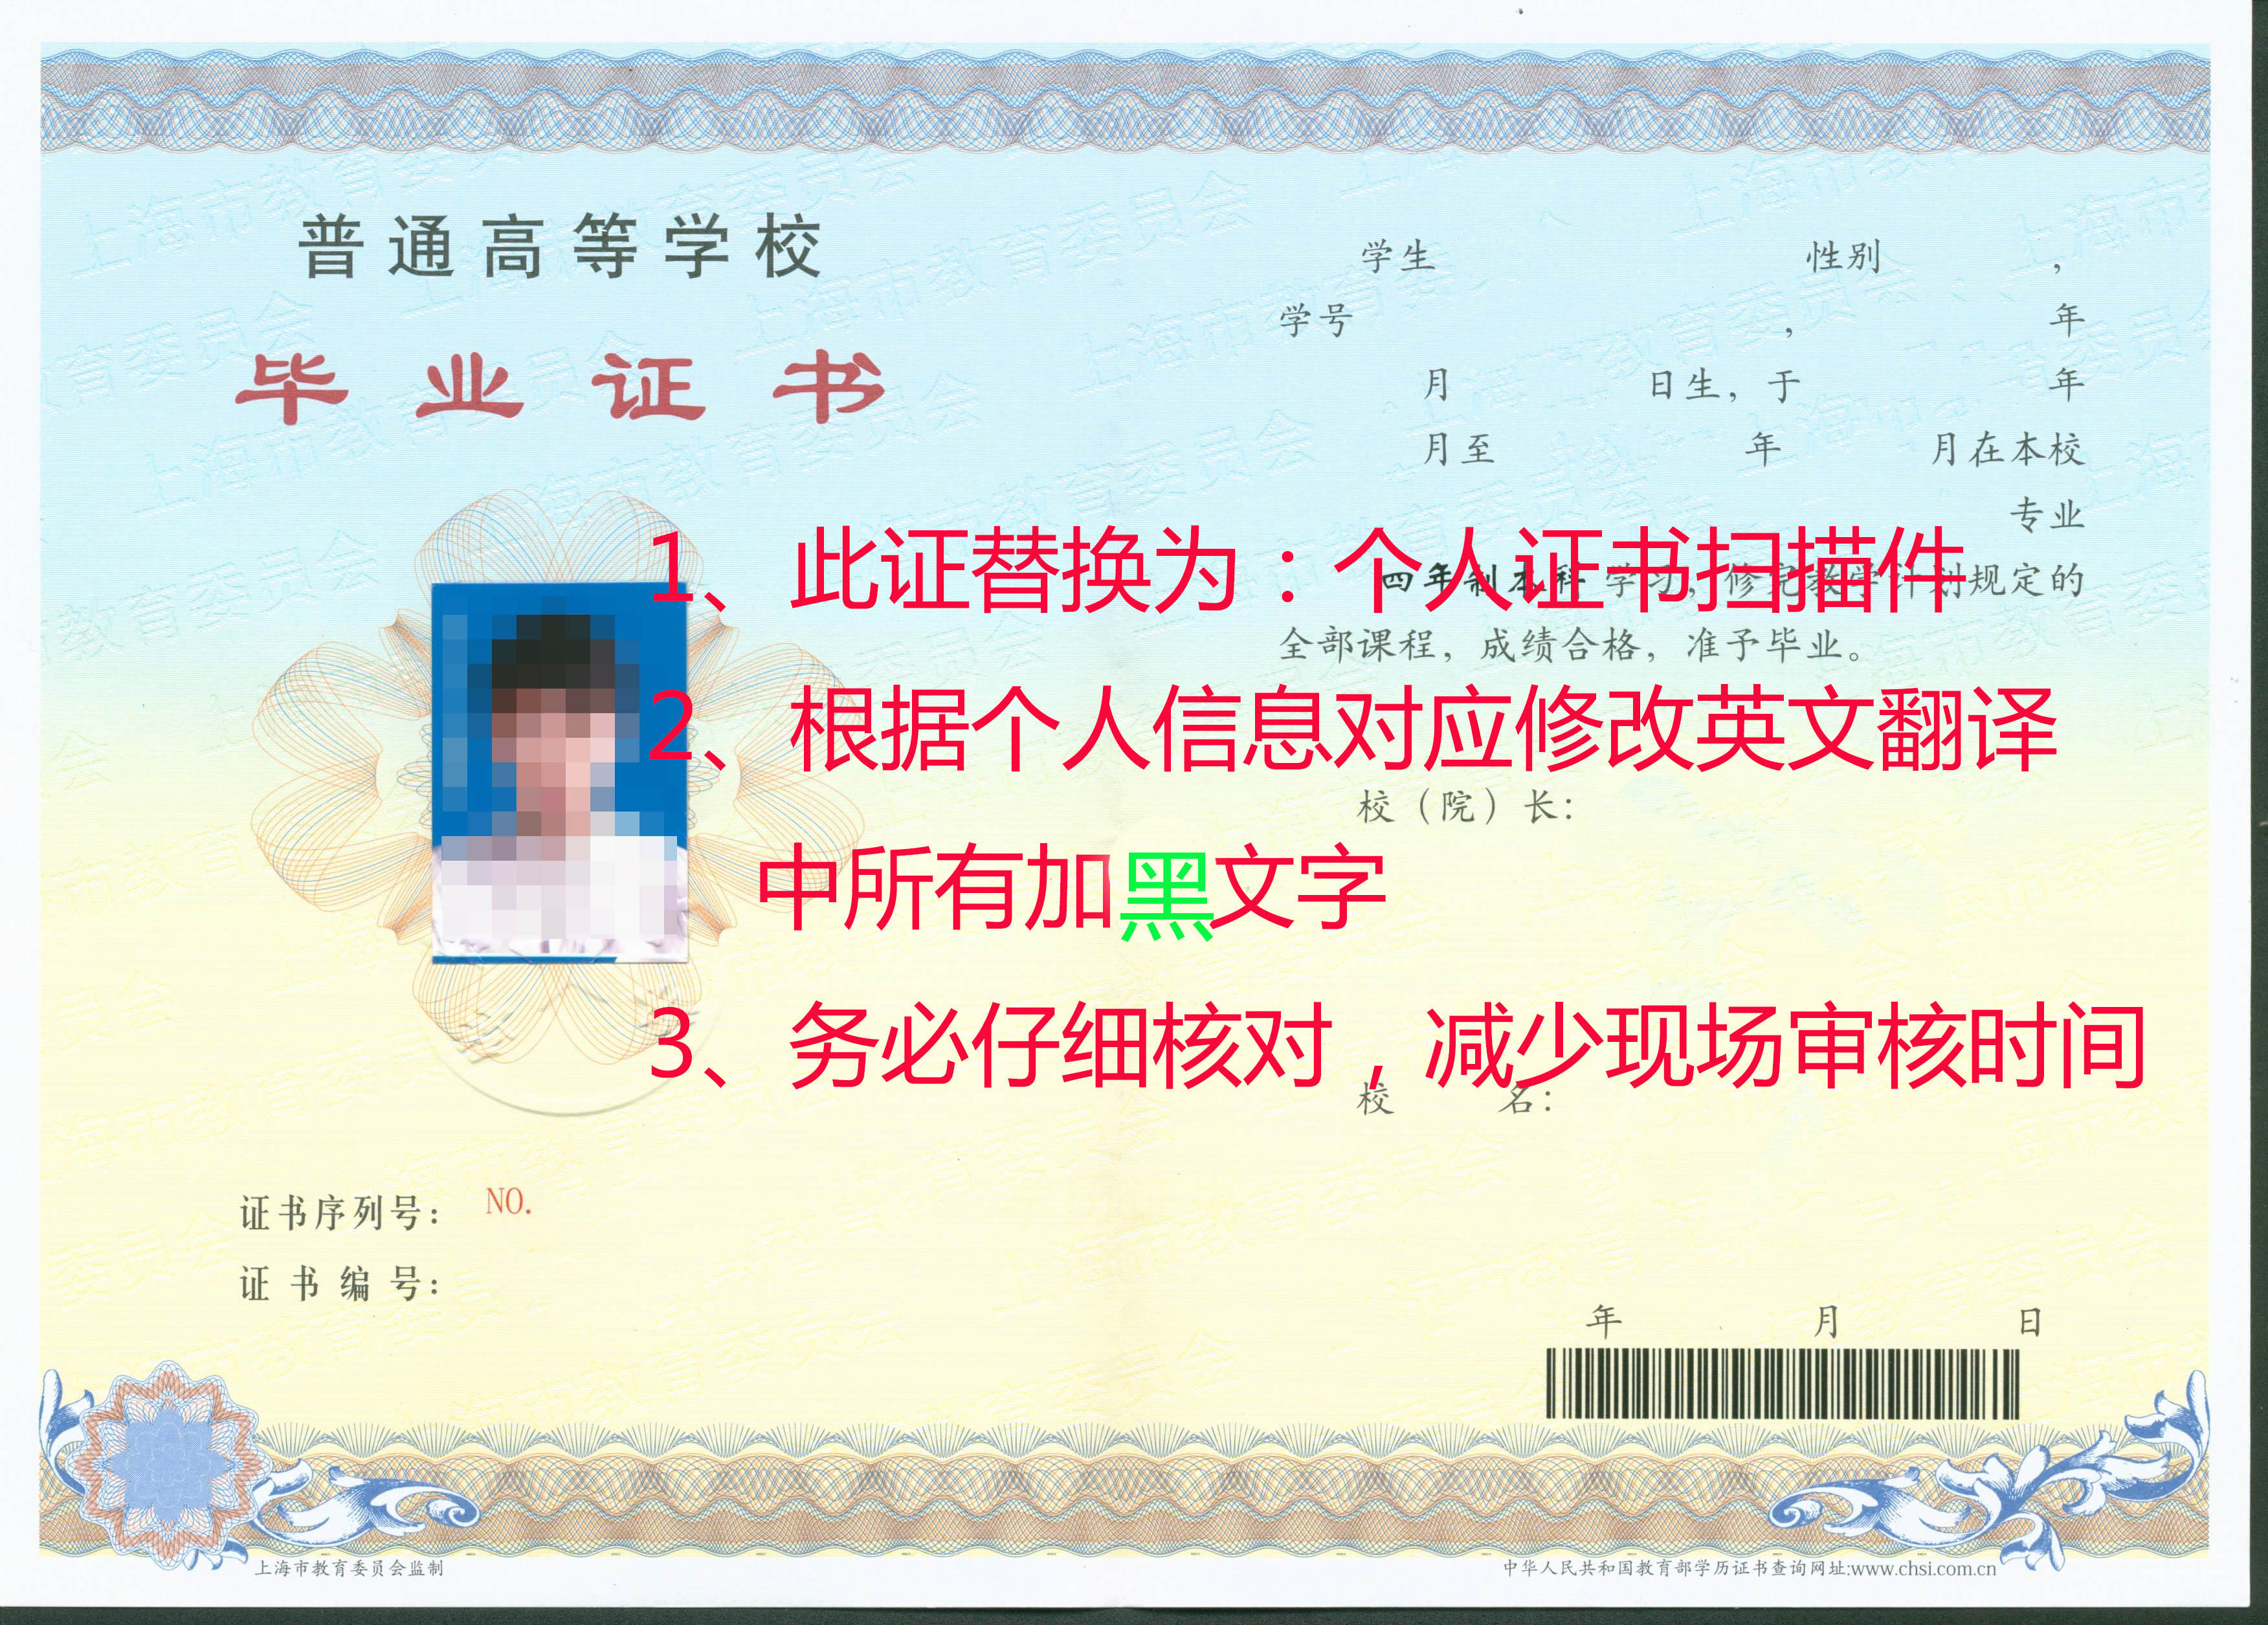DIPLOMA
( Translation )

This is to certify that Sanmao Zhang, Male, born on 28th July, 1996，studied in this university with a speciality of Material Chemistry from August 2015 to July 2019.Upon completing and passing all the required courses of the 4- year undergraduate program, Sanmao Zhang is granted graduation.

President: Qu Jingping
East China University of Science and Technology
Certificate Serial No: 1234567890
Certificate No:1234567890 Issued on 1st July,2019

